Jev Decision Layer: Executive Proposal
Sep 27, 2026 · @I wanted to understand how google adk I can get output from subg
Prepared for: Executive leadership · Prepared by: Enterprise AI Architecture · Classification: Internal

Executive summary
This paper recommends adopting Jev, a low-cost decision model from TypeSafe AI, as a shared decision layer alongside our Gemini agents. The first deployment would be QA reconciliation for EDR and RRO.
Business case. Most model calls in our compliance pipelines are classification decisions, not text generation. Routing them to Jev reduces LLM spend and latency, and provides a calibrated confidence score that determines when a case needs Gemini or a human reviewer.
Risk posture. The principal risks are data residency, vendor maturity and numeric precision. Each is mitigated by design: field-level routing, an interchangeable local model, and deterministic rules for numbers and dates.
Recommendation. Approve a shadow-mode pilot, a compliance and vendor review of TypeSafe, and funding for a shared decision interface reusable across platforms.

Business context
Most LLM calls in our compliance pipelines are decisions rather than writing tasks: match or mismatch, relevant or not, which path to take. Today we pay generative-model prices for outputs that are a single label.
This creates three structural costs:
- Spend grows with volume. Every field comparison, routing step and judge call pays for input and output tokens, and output is the expensive part.
- Confidence is unreliable. An LLM's stated confidence is text it wrote, not a measured probability, so we cannot safely auto-close cases on it.
- Improvement loops are expensive. Prompt optimization (GEPA) and LLM-as-judge evaluation multiply token use, which limits how often we can run them.

Solution overview
Jev is a decision model from TypeSafe AI: we define the options, and it returns a probability for each one. It never writes text, so answers always match the schema we asked for.
 | Jev | Frontier LLM (Gemini)
Output | A choice, score or yes/no with probabilities | Generated text we must parse
Best at | Classifying, matching, routing, scoring | Reasoning, extraction, explanation
Input price | $0.042 per 1M tokens | Higher per token
Output price | Free | Typically the most expensive part
Response time | 70 to 500 ms, as published | Seconds for long outputs
Context per call | 64,000 tokens (32,000 for the case data) | Much larger
Weak spots | Numeric and date precision; distracted by irrelevant context | Cost, variable output, unmeasured confidence
Jev is not a replacement for Gemini. It takes over the high-volume yes/no and pick-one decisions, and Gemini handles everything that needs reasoning or words. Jev figures are from TypeSafe's published limits (source).

Target architecture
A single decision router sends each field or decision to the cheapest engine that can answer it reliably. The routing table lives in configuration, so moving a field between engines needs no code change.
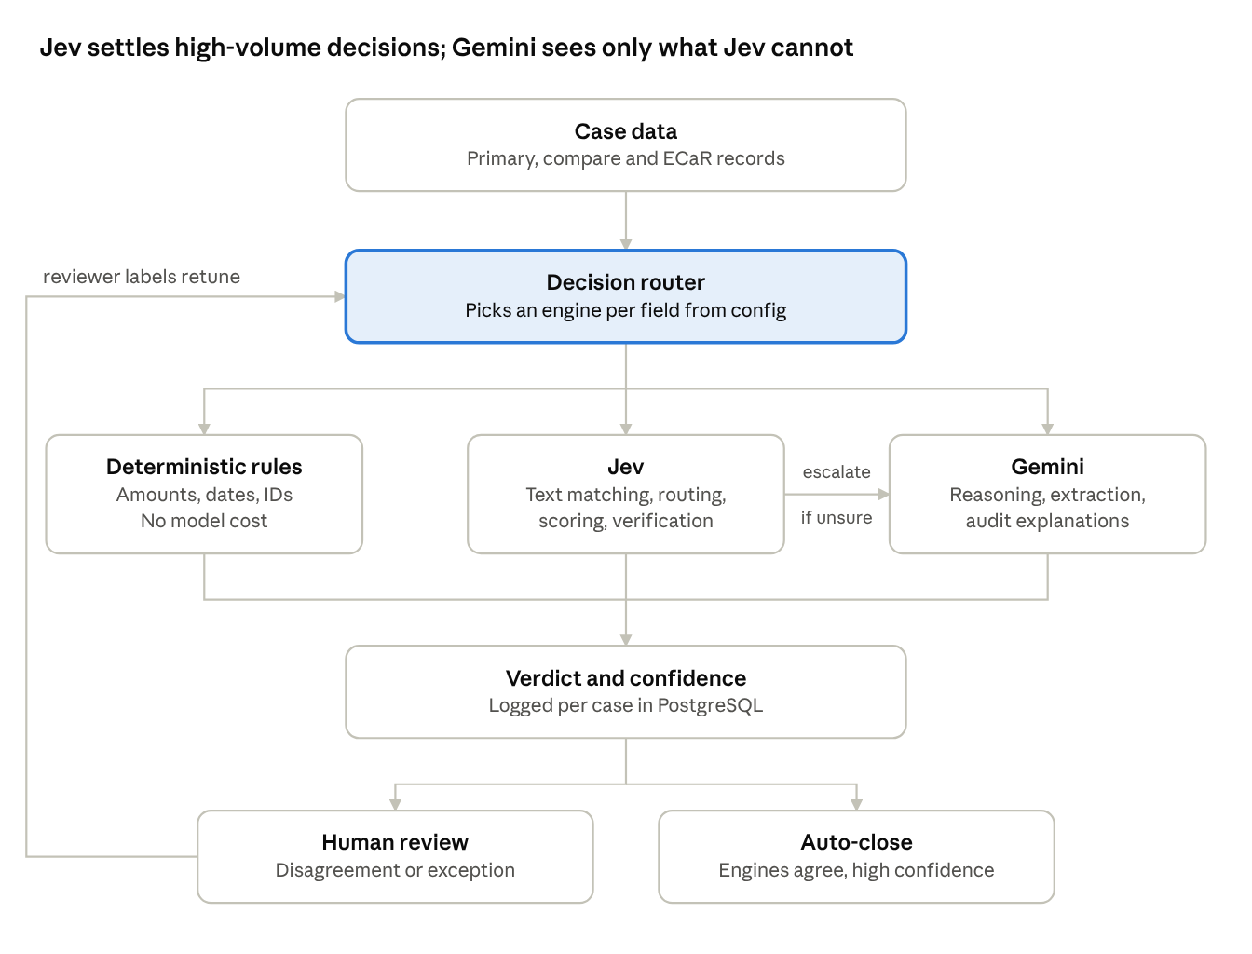
target architecture · one router, three decision engines
Deterministic rules take numbers, dates and IDs; Jev takes text decisions; Gemini gets only escalations and explanations. Reviewer labels flow back to retune the router's confidence thresholds.

Use-case portfolio
We identified 15 opportunities to move decisions from the LLM to Jev, across QA, agent orchestration, guardrails and data platforms. Four are quick wins that reuse the pilot's code and prove the pattern.
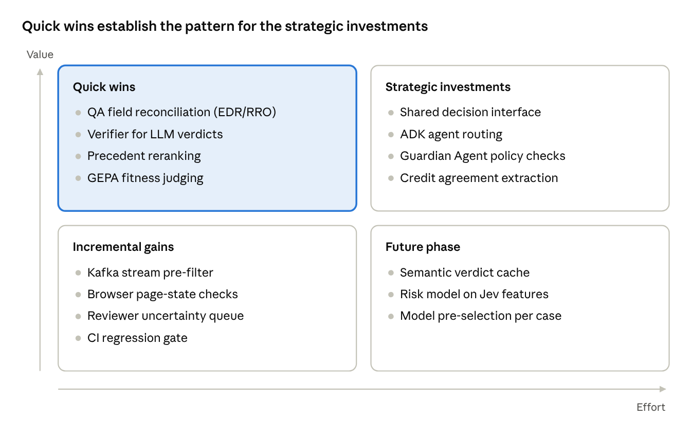
use-case portfolio · 15 opportunities by value and effort
Placement is our engineering estimate, to be confirmed after the pilot.
Use case | Platform | What Jev decides
QA field reconciliation | EDR/RRO QA agent | Match, minor variance or mismatch across three sources
Verifier for LLM verdicts | EDR/RRO QA agent | Does the cited evidence support Gemini's verdict?
Precedent reranking | QA feedback store | Is this past case relevant to the current one?
GEPA fitness judging | Prompt optimization | Scores candidate prompts on each KPI
Shared decision interface | All agent platforms | One contract for Jev, a local model or Gemini, chosen per field
ADK agent routing | ADK coordinators | Which sub-agent handles this turn
Guardian Agent policy checks | Guardian Agent | Is this tool call or output within policy?
Credit agreement extraction | Extraction pipeline | Which section holds each field; which passage supports each ground-truth value
Kafka stream pre-filter | Kafka consumer platform | Does this event need a workflow at all?
Browser page-state checks | Browser automation | Is this the expected screen, an error or a login wall?
Reviewer uncertainty queue | Feedback UI | Which cases a human should label first
CI regression gate | Delivery pipeline | Full golden-set scoring on every config change
Semantic verdict cache | EDR/RRO QA agent | Is this case materially the same as one already decided?
Risk model on Jev features | Disposition | Jev probabilities as inputs to an interpretable model
Model pre-selection per case | All agent platforms | Does this case need Flash, Pro or no LLM?

Use case in focus: credit agreement extraction
Credit agreement extraction is the strongest candidate after QA reconciliation. Jev addresses its two hardest problems: finding the right passage in long, unstandardized documents, and recovering the evidence behind existing ground truth.
Current state | Detail
Corpus | About 20,000 credit agreements, converted to text with Document AI
Document format | 40 to 60 pages each, with no standard template across borrowers
Target fields | 200, split between values stated in the document and values derived from rules or relationships
Extracted reliably today | About 40 fields
Ground truth | Values for all 200 fields, entered by reviewers, with no page or span provenance
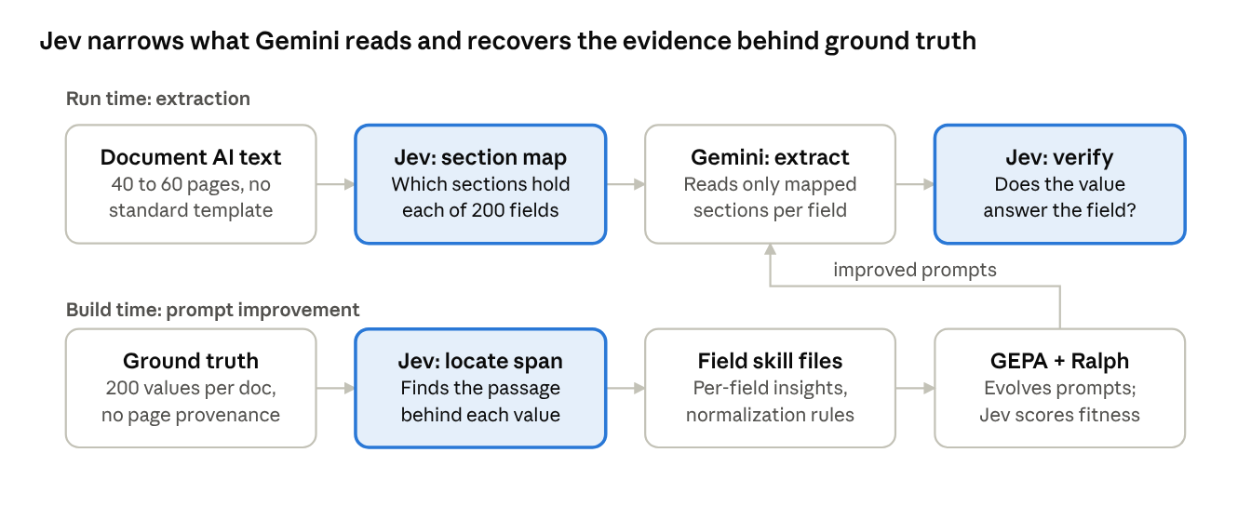
credit agreement extraction · where Jev fits at run time and build time
Jev steps are highlighted. It adds value in four places:
- Section mapping. Jev scores each section for relevance to each field, so Gemini reads a few pages instead of the whole agreement. This cuts tokens and removes distracting context.
- Evidence recovery. For each ground-truth value, Jev identifies the passage that supports it. This creates the provenance the labels lack, which the prompt compiler needs to learn from.
- Answer verification. After extraction, Jev checks whether the value actually answers the field. Low-confidence values go to review.
- Lower-cost prompt optimization. Jev scores candidate prompts in the GEPA and Ralph loop in place of an LLM judge, so the loop can run over far more documents.
Jev does not replace Gemini here. Value normalization and discovering the logic behind derived fields stay with Gemini and deterministic rules. Jev also runs per section, because a full agreement can exceed its 32,000-token limit for case data.
The success measure is the number of fields extracted reliably, moving from about 40 toward all 200.

Financial impact
For a single decision, TypeSafe's published example puts Jev at about 170 times cheaper than an LLM. The real saving for us depends on how many decisions we move and how often Jev escalates.
Measure | Jev | Frontier LLM
Input price per 1M tokens | $0.042 | $0.20 to $10
Output price | Free | About 5x the input rate
One illustrative decision call | $0.000081 | $0.013880
Batching also matters: TypeSafe measured 13 questions in one request at 12.2 times cheaper and 10 times faster than 13 separate requests. Our reconciliation design already batches three comparisons per field.
The LLM spend that remains after Jev is roughly:
\text{LLM cost}_{\text{after}} = \text{LLM cost}_{\text{today}} \times \left(1 - s \times (1 - e)\right)
Here s is the share of LLM decisions moved to Jev or rules, and e is the escalation rate back to Gemini. Moving 60% of decisions with a 20% escalation rate cuts that LLM spend by 48%. The pilot will measure both numbers on our own cases.
All prices are vendor-published figures, and the per-call example is TypeSafe's best case (pricing, limits). TypeSafe states it cannot yet prove its pricing is not subsidized.

Risk assessment and controls
Each risk below is mitigated by a design control, and no decision depends on Jev alone. Data residency is the one that needs a compliance decision before production.
Risk | Why it matters | Control
Data leaves our environment | Jev is a US-hosted cloud API; loan and borrower data would cross the boundary | Compliance review first; per-field routing keeps sensitive fields on a local model or Gemini
Early-access vendor | Waitlist access, no published SLA, pricing may change | Shared decision interface with a local model and Gemini as fallbacks; circuit breaker on errors
Numeric and date errors | Jev is weak on numeric and date precision | Amounts, dates and IDs always use deterministic rules
Silent model changes | The jev-latest alias moves without warning, which shifts every calibrated threshold | Pin the model version and record it with every decision
Miscalibrated confidence | Auto-closing on a wrong confidence score hides errors | Track calibration per field against reviewer labels; tighten thresholds if it drifts
No written rationale | Auditors need reasons, and Jev returns only probabilities | Gemini writes explanations for every exception; all decisions logged in PostgreSQL
Rate limits | 1,200 requests per minute per account | Batch questions per call; back off and retry on 429 and 529 errors

Implementation roadmap
We start with a shadow pilot that changes no decisions, and each later phase opens only when its gate criteria are met. Durations will be set once pilot volumes are known.
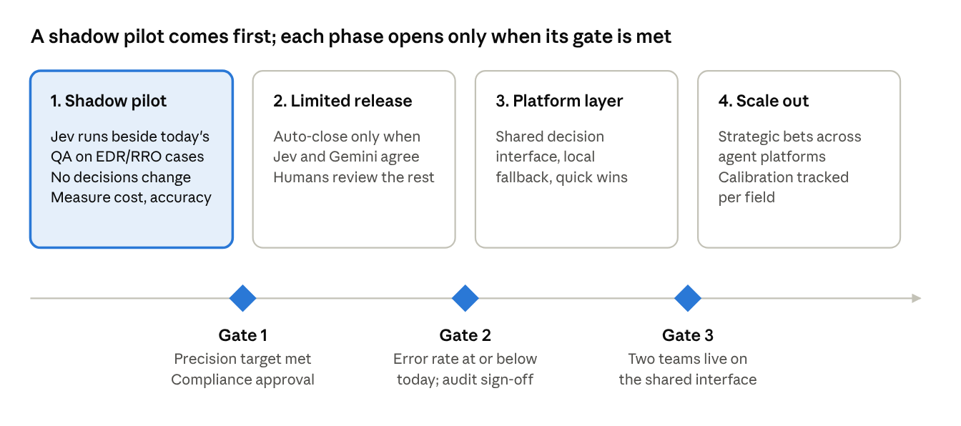
roadmap · 4 phases, 3 gates
The pilot measures the two numbers that drive savings, the share of decisions moved and the escalation rate, plus Jev's precision on mismatches against reviewer labels.

Decisions requested from leadership
We need three approvals to start the pilot. None of them commits us to production use of Jev.
- Approve the shadow pilot on EDR/RRO QA reconciliation, running beside today's process with no change to live decisions.
- Start a compliance and vendor review of TypeSafe covering data residency, data retention and contract terms. This is the gate before any production data flows.
- Fund the shared decision interface as a platform capability, so Jev, a local model and Gemini are interchangeable per field and other teams can reuse it.

References
- Jev rate limits, context window and pricing, from TypeSafe's published models page and API reference
- TypeSafe Jev pricing explained, including TypeSafe's per-call cost example and its statement on pricing sustainability

